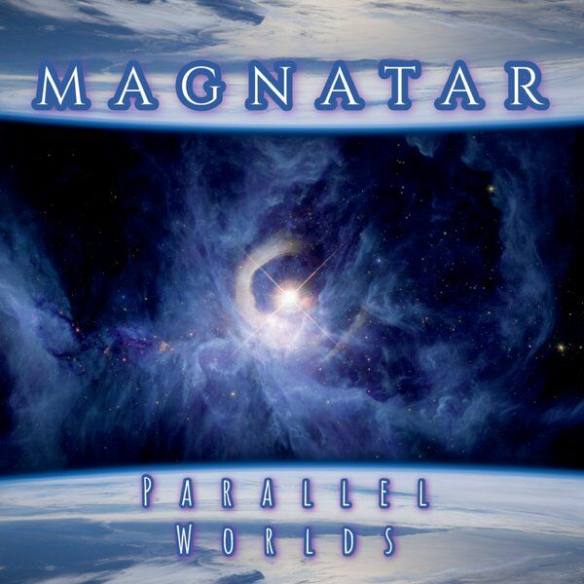 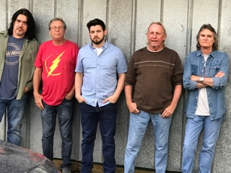

Dissonant arpeggios introduce *Night Changes,* launched by a wild rhythmic pulse and unbridled keyboards. The solo guitar of **Ryan RIVAS** returns to the outposts, the mandolin inserting to fluidify the hot music of **MAGNATAR.** **Ryan RIVAS's** power chords appear formidable, sweeping everything in their path, helped by the bouncy drummer **Reed HAYES** and **Joey COSTA's** humming bass.

*A Walk In The Park* is introduced by an acoustic guitar sequence, tense and virtuoso, cutting with the previous electric furnace. The game **Ryan RIVAS** is particularly exciting on this instrument, especially as it is a solo performance with multiple colors and rhythms.

*Five Pieces of Six,* the electric guitar and keyboard floods introduce this title, quickly joined by a low arcboutée and a swift drums for a powerful and virtuoso set, in a mid heavy register. The electric guitar takes the central role, multiplying the riffs, accompanied by the intertwined mandolin game of **Glenn SMITH.** Many breaks, jerks and movement on this title ensure its perpetual evolution. Enjoy the voluptuous guitar choruses accompanied by mandolin and incendiary bass.

*She Flies,* augmented electric guitar of opening electronics, guitar riffs, mandolin and tablecloths of keyboards succeed one another, conferring a more symphonic color, more vaporous. The overall sound appears totally original with the contrast electric guitar / acoustic mandolin exacerbated, the rhythm section infusing dynamic always very tonic.

*Augmented Reality* begins with virtuoso acoustic guitar, followed by solid bass drum breaks while accelerating. Change of theme and rhythm, the piece starts on a crazy tempo, crossed by electric welts at regular intervals dotted with mandolin and scrolls Hammond organ. The originality of **MAGNATAR's** music never fails, especially as it has reached, through years of preparation and concerts, a great maturity.

This first album of **MAGNATAR** imposes itself as a total revelation. Each piece arouses enthusiasm and the group has forged a strong compositional identity, which is not given to everyone. If you are a fan of **YES, STARCASTLE, SYZYGY** you should not be insensitive to this solar music, a constant and superb creativity.

**(*****) Didier GONZALEZ**

**MAGNATAR** is an American quintet from DeLand, Florida. The composition of the group extends over 3 generations of musicians who have forged together an original instrumental sound mixing a power rock with progressive elements inspired by **YES**. In addition to the electric guitar, bass, keyboards and drums, the mandolin brings an original sound, tending to unify the music.

The founding members of the group, whose origins date back 12 years, are **Glenn SMITH** on Mandolin and **Joey COSTA** on bass. **Glenn SMITH** quickly emerges as the main composer. Along with other musicians, at this time they are called as **BUCKETS AND STRINGS.**

In 2011, **Glenn SMITH** met drummer **Reed HAYES** at a **BUCKET AND STRINGS** concert at the DeLand Original Music Festival. A few months later, **HAYES** joins the group.

Shortly after, the band decided to change its name to **JEBRA's PARADISE**. The following year, guitarist **Ryan RIVAS** is integrated, through **Joey COSTA, who** had known him for a long time. This new integration causes a new change of name, the group becoming therefore **MAGNATAR**. The next step comes when the cousin of **Glenn**, also an old friend of **Joey**, keyboardist **Dave NORTON** connects with the group.

In the distant past, **Dave NORTON** and **Joey COSTA** had been part of the **HOT CITY** band, which released a single, *Leaving,* on London Records in 1971. This group performed numerous concerts in the Southeast Club circuit under the name **FANTASIA.**

The addition of keyboards brings the extra touch that would increase the originality of the sound of **MAGNATAR.** After two years of intense work, **MAGNATAR** publishes its first album **PARALLEL WORLDS**, self-produced, October 23, 2018.

**9** tracks for **53'21** of music constitute this inaugural album.

From the first notes of *Parallel Worlds,* we find the stylistic style of **YES** and the **US SYZYGY** formation, with a music with strong tonicity, developing a certain power and exposing from the outset a real instrumental virtuosity, including the guitar of **Ryan RIVAS.** The many breaks, the dazzling acceleration of rhythm are one of the musical characteristics of **MAGNATAR.** The non-dominant keyboards are intelligently integrated with the music, to give a subtle symphonic frame to the music of the quintet.

Fourth Passage continues, even accentuating the energetic dimension of **MAGNATAR's** music, with powerful jerks of **Joey COSTA's** bass reminiscent of **Chris SQUIRE's** explosive play, embellished with the rhythmic turpitude of **Reed HAYES'** explosive drum set. The guitar both incisive and incendiary, allows **Ryan RIVAS** to continue to assert his strong presence-personality. The **Glenn SMITH** mandolin softens the overall sound of the band, while assuring it of an also original sound.

*Solara (Intro To New Galaxy)* is marked by the fine and delicate pianistic touch of **Dave NORTON** coming to bring a little balm on this burning music, for with a score of powerful classic fragrances, intended to introduce the next piece.

*New Galaxy* starts all power and energy on a triptych guitar-bass-battery boost, soon joined by a folk accompaniment conferred by the mandolin and at regular intervals by beautiful electric guitar chorus, while providing feeling and sensitivity. **MAGNATAR’s** energetic dimension yet full of tension is confirmed, especially through **Joey COSTA’s** intrepid bass playing, infusing energy and an original color. **Dave NORTONS’s** keyboards are grafted, contributing to the thickness of the sound.

**MAGNATAR**

MAGNATAR

**PARALLEL WORLDS (**[**www.magnatarworld.com**](http://www.magnatarworld.com)**, USA, 2019)**

**(**

**(**

#### CD Cover CD Cover Best Rez.jpegRez.jpeg